**CUSTOMER CHURN PREDICTION**

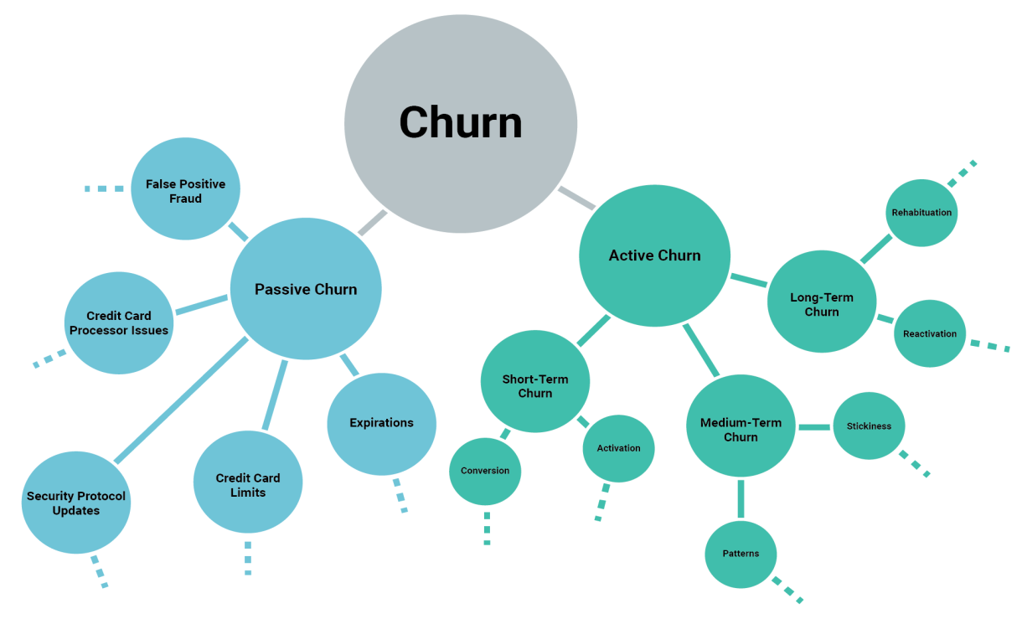

Customer churn prediction in machine learning is the process of using historical customer data to build predictive models that can identify and anticipate when customers are likely to stop using a product or service. The goal is to reduce customer attrition by taking proactive actions to retain those customers who are at risk of leaving.

Here's a step-by-step guide on how to approach customer churn prediction using machine learning:

1. **Data Collection**:

Gather historical customer data, which typically includes information such as customer demographics, transaction history, usage patterns, customer support interactions, and more. This data is crucial for building a predictive model.

2**. Data Preprocessing**:

Clean and preprocess the data. This involves handling missing values, encoding categorical variables, and scaling numerical features. You may also need to create new features or aggregate data to extract relevant information.

3**. Feature Selection**:

Identify the most important features that are likely to influence churn. Feature selection techniques, such as feature importance analysis or correlation analysis, can help you determine which variables to include in your model.

**4. Split Data**:

Divide your dataset into two parts - a training set and a testing set. The training set is used to build and train the model, while the testing set is used to evaluate its performance.

5. **Model Selection**:

Choose an appropriate machine learning model for your churn prediction task. Common models for churn prediction include logistic regression, decision trees, random forests, support vector machines, and neural networks. Select the model that best suits your dataset and the problem at hand.

6. **Model Training**:

Train the selected model on the training data. During training, the model learns to identify patterns and relationships in the data that are indicative of customer churn.

7. **Model Evaluation**:

Evaluate the model's performance on the testing dataset using appropriate evaluation metrics. Common metrics for churn prediction include accuracy, precision, recall, F1-score, and ROC AUC. Choose the metrics that align with your specific business goals.

8. **Tune Hyperparameters**:

Fine-tune the model by adjusting hyperparameters to improve its performance. This may involve techniques such as cross-validation and grid search.

9. **Deployment**:

Once you are satisfied with the model's performance, deploy it in a real-world setting to monitor and predict customer churn in real time.

10. **Continuous Monitoring**:

Churn prediction is an ongoing process. Regularly retrain and update your model as new data becomes available. This ensures that the model remains accurate and relevant over time.

11. **Take Action**:

Use the churn predictions to implement proactive retention strategies. This might include targeted marketing campaigns, personalized offers, or improved customer support for at-risk customers.

Churn prediction is a valuable application of machine learning for businesses, as it can help them reduce customer attrition, increase customer lifetime value, and ultimately improve their bottom line. However, it's important to note that achieving high accuracy in predicting churn is just one part of the equation; taking effective actions to retain customers is equally important.

**Source code:**

# Import necessary libraries

import pandas as pd

import numpy as np

from sklearn.model_selection import train_test_split

from sklearn.preprocessing import StandardScaler

from sklearn.linear_model import LogisticRegression

from sklearn.metrics import confusion_matrix, classification_report

import matplotlib.pyplot as plt

# Load your dataset (replace 'your_data.csv' with your dataset file)

data = pd.read_csv('your_data.csv')

# Data Preprocessing

# Assume 'Churn' is the target variable, and other columns are features

X = data.drop('Churn', axis=1)

y = data['Churn']

# Split the data into training and testing sets

X_train, X_test, y_train, y_test = train_test_split(X, y, test_size=0.2, random_state=42)

# Feature Scaling

scaler = StandardScaler()

X_train = scaler.fit_transform(X_train)

X_test = scaler.transform(X_test)

# Train a Logistic Regression model

model = LogisticRegression()

model.fit(X_train, y_train)

# Make predictions

y_pred = model.predict(X_test)

# Model Evaluation

confusion = confusion_matrix(y_test, y_pred)

print("Confusion Matrix:\n", confusion)

report = classification_report(y_test, y_pred)

print("Classification Report:\n", report)

# Visualize the results (optional)

# You can use libraries like matplotlib or seaborn to plot graphs.

# For example, to plot a bar chart of feature importance if your model supports it:

if hasattr(model, 'coef_'):

feature_importance = model.coef_[0]

plt.figure(figsize=(10, 6))

plt.bar(X.columns, feature_importance)

plt.xlabel("Features")

plt.ylabel("Coefficient Value")

plt.title("Feature Importance")

plt.xticks(rotation=45)

plt.show()

In this code:

1. Load your dataset and preprocess it by splitting it into features (X) and the target variable (y).
2. Split the data into training and testing sets.
3. Standardize the features using **StandardScaler**.
4. Train a logistic regression model on the training data.
5. Make predictions on the testing data.
6. Evaluate the model using a confusion matrix and a classification report.
7. Optionally, visualize feature importance using a bar chart.

Make sure to replace **'your_data.csv'** with the actual path to your dataset file. Additionally, you may need to adjust the code to match the specific characteristics of your dataset and choose a different machine learning algorithm based on your dataset and requirements.